**What is SQL Server**

* SQL Server is a relational database management system, or RDBMS, developed and marketed by Microsoft.
* It is primarily designed and developed to compete with MySQL and Oracle database.
* Like other [RDBMS](https://searchdatamanagement.techtarget.com/definition/RDBMS-relational-database-management-system) software, Microsoft SQL Server is built on top of [SQL](https://searchsqlserver.techtarget.com/definition/SQL), a standardized programming language that database administrators ([DBAs](https://searchsqlserver.techtarget.com/definition/database-administrator)) and other IT professionals use to manage databases and query the data they contain.
* SQL Server is tied to Transact-SQL ([T-SQL](https://searchsqlserver.techtarget.com/definition/T-SQL)), an implementation of SQL from Microsoft that adds a set of proprietary programming extensions to the standard language.

# Install SQL Server

# Note: Install SQL Server and SQL Server Management Studio from the Microsoft official site. Below shows the installtion of 2017 editions. You can install any version.

* To install SQL Server, you need to download it from the Microsoft.com website via the following link:
* <https://www.microsoft.com/en-us/sql-server/sql-server-downloads>
* Download developer or express editions
* Once the download completes, you double-click the file **SQLServer2017-SSEI-Dev.exe** to launch the installer.
* The installer asks you to select the installation type, choose the Custom installation type allows you to step through the SQL Server installation wizard and select the features that you want to install.

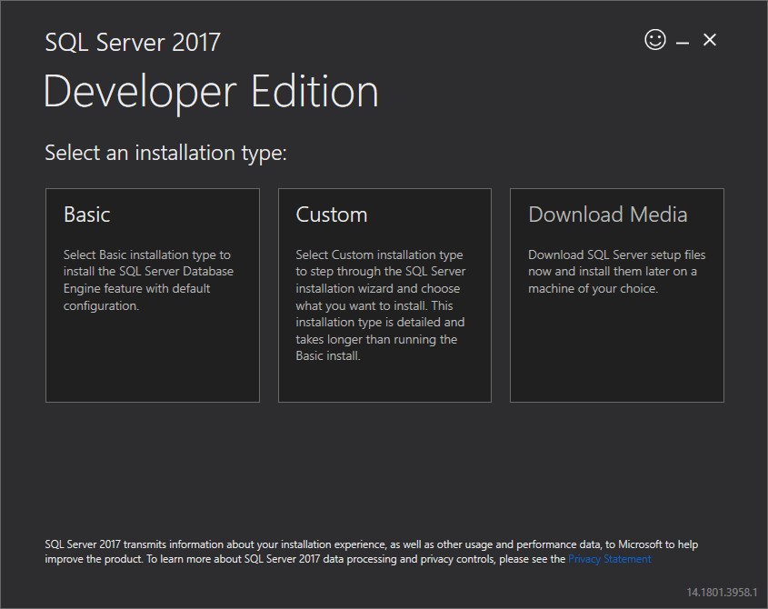

* Specify the folder for storing the installation files that the installer will download, then click the Install button.

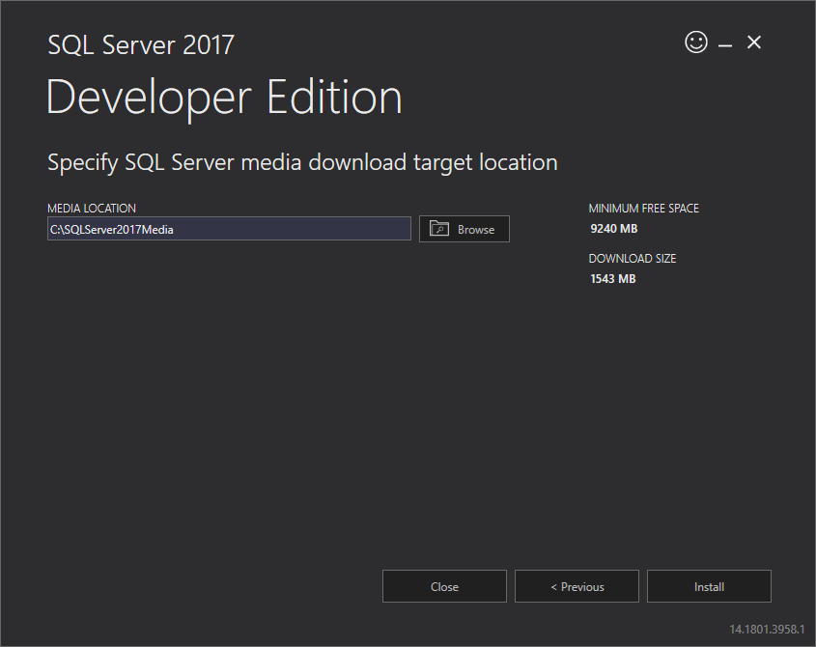

* The installer starts downloading the install package for a while.

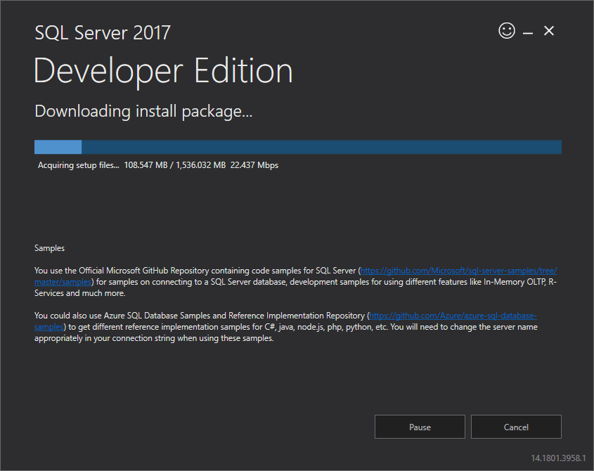

* Once the download completes, open the folder that stores the install package and double-click the SETUP.exe file.

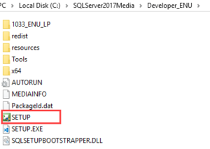

* The following window displays; select the installation option on the left.

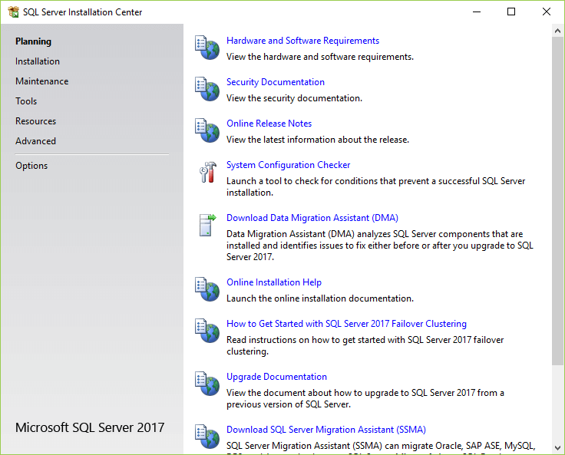

* Click the first link to launch a wizard to install SQL Server 2017.

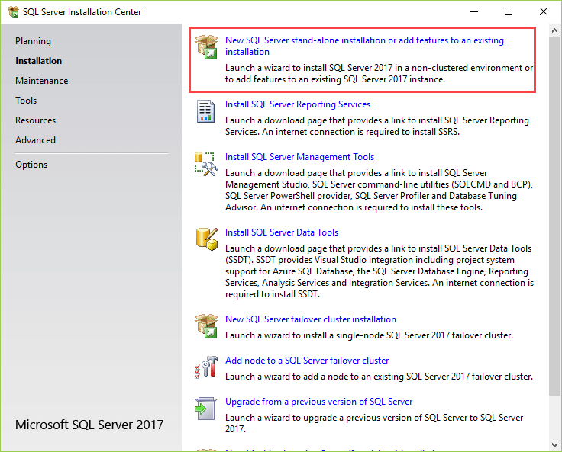

* Specify the edition that you want to install, select Developer edition and click the Next button.

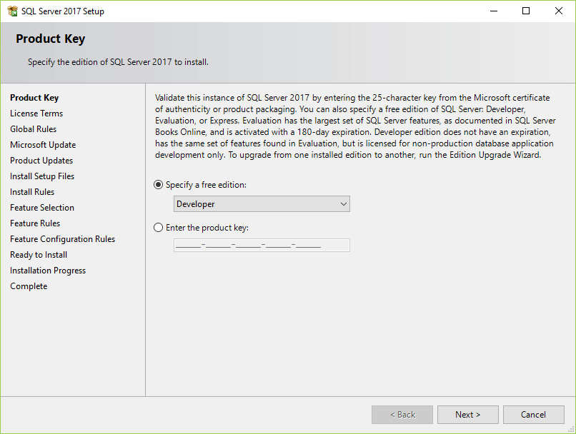

* Select the “I accept the license terms.” and click the Next button.

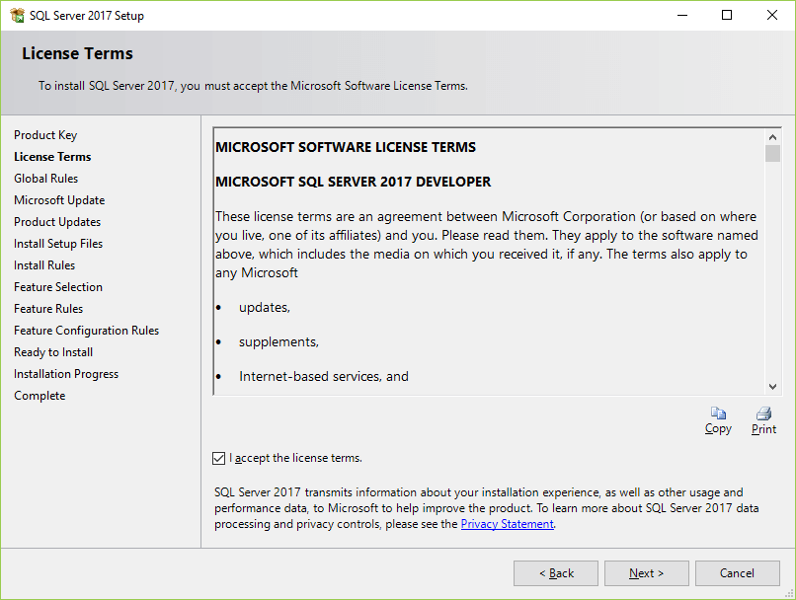

* Check the “Use Microsoft Update to check for updates (recommended)” to get the security and other important updates for the SQL Server and click the Next button.

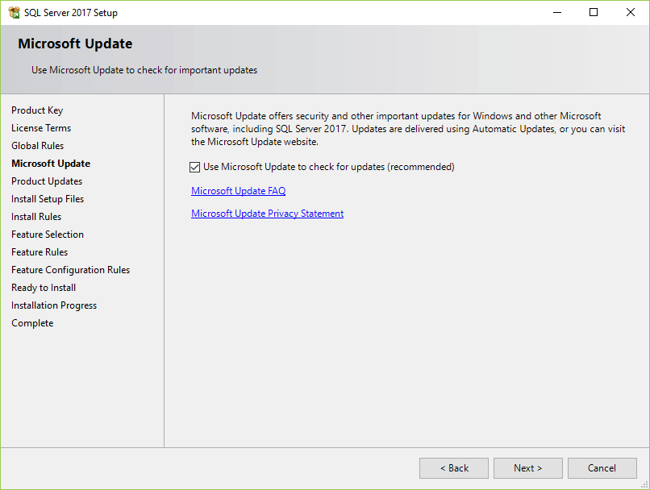

* The installation checks for the prerequisites before installation. If no error found, click the Next button.

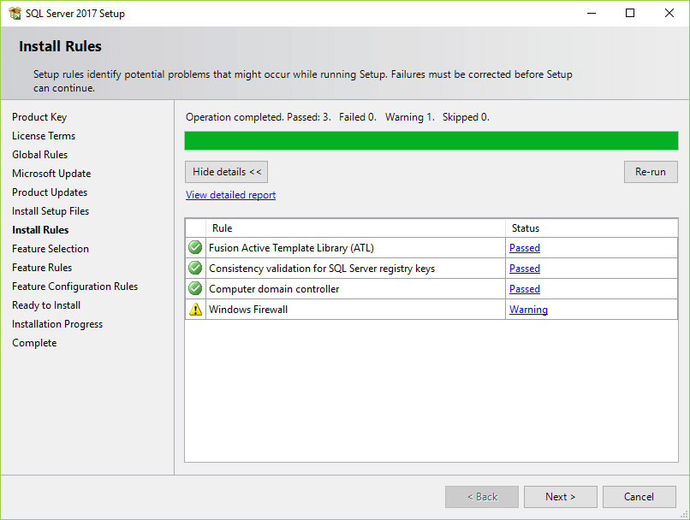

* Select the features that you want to install. For now, you just need the Database Engine Services, just check the checkbox and click the Next button to continue

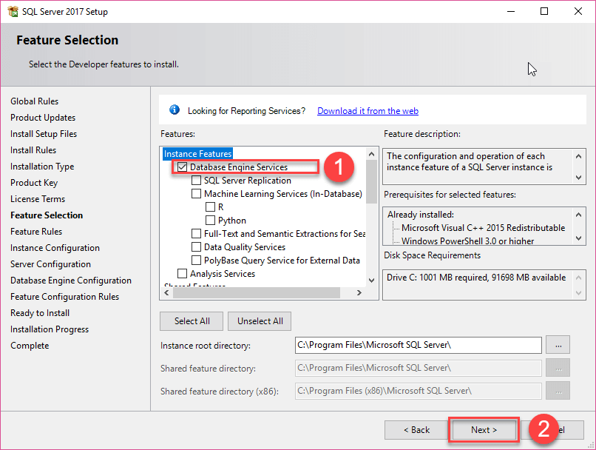

* Specify the name and install ID for the instance of the SQL Server and click the Next button.

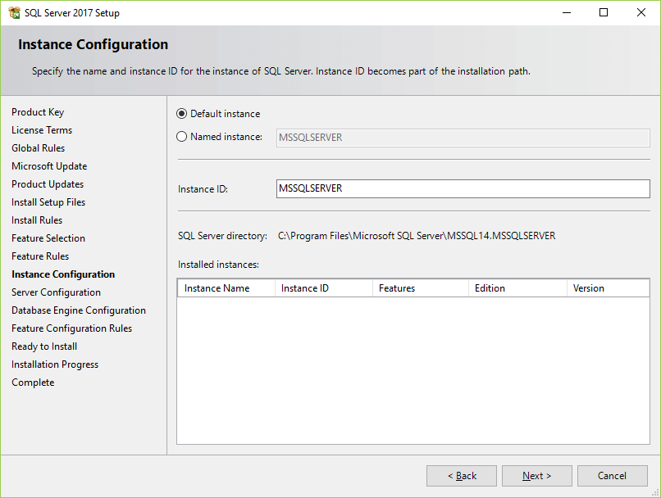

* Specify the service account and collation configuration. Just use the default configuration and click the Next button.

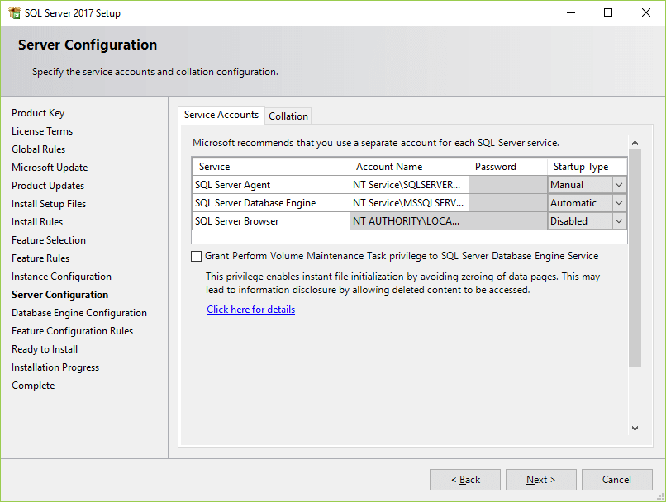

* Specify the database engine security mode. First, choose Mixed Mode. Next, enter the password for the SQL Server system administrator (sa) account. Then, re-enter the same password to confirm it. After that, click the Add Current User button. Finally, click the Next button.

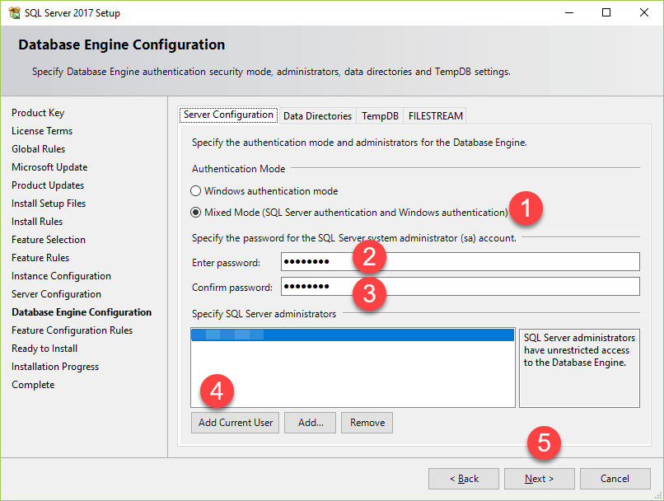

* Verify the SQL Server 2017 features to be installed:

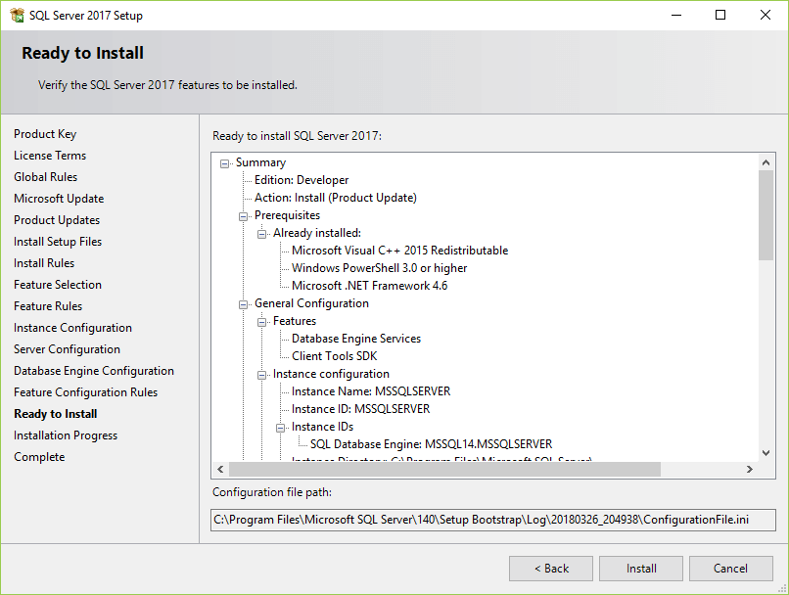

* The installer starts the installation process

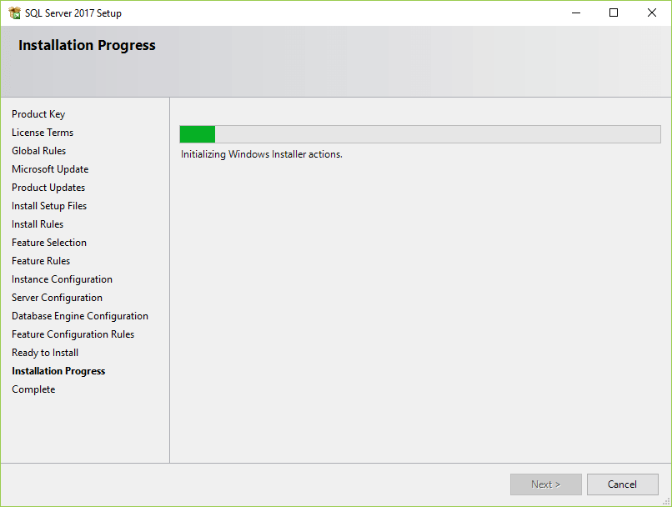

* Once it completes, the following window displays. Click the OK button.

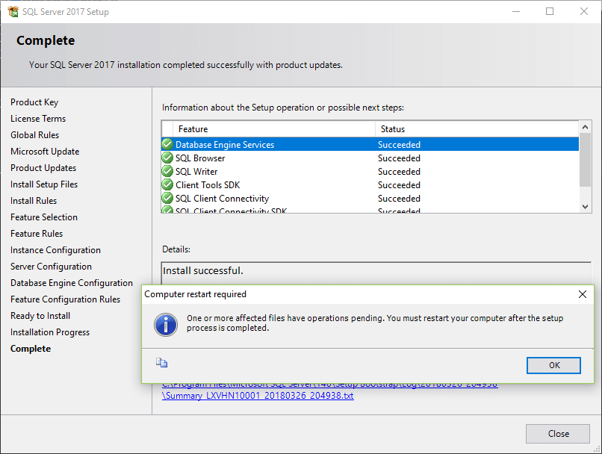

* Click the Close button to complete the installation

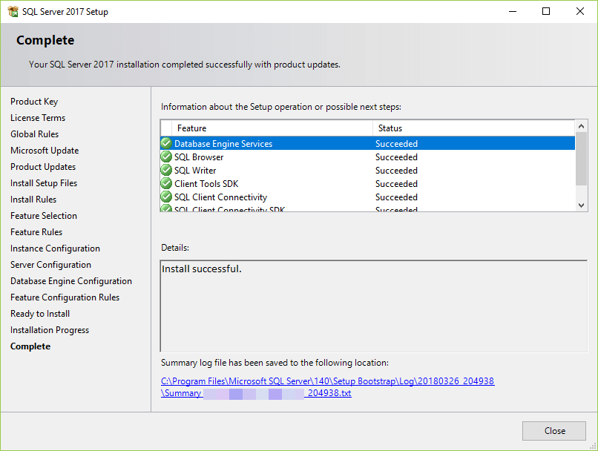

* Congratulation!  you have successfully installed SQL Server Developer Edition.

## **Install Microsoft SQL Server Management Studio**

* To interact with SQL Servers, you need to install SQL Server Management Studio (SSMS). The SQL Server Management Studio is a software for querying, designing, and managing SQL Server on your local computer or in the cloud. It provides you with tools to configure, monitor, and administer SQL Server instances.
* First, download the SSMS from the Microsoft website via the following link
* <https://docs.microsoft.com/en-us/sql/ssms/download-sql-server-management-studio-ssms?view=sql-server-ver15>
* Second, double-click the installation file **SSMS-Setup-ENU.exe** to starting installing. The installation process of SMSS is straightforward which you just need to follow the screen sequence.
* Click the **Install** button

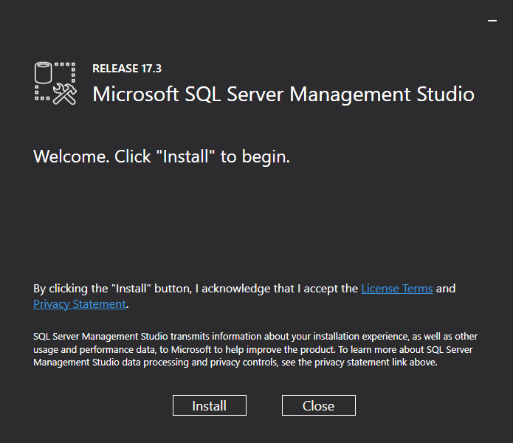

* Wait for few minutes while the installer sets up the software.

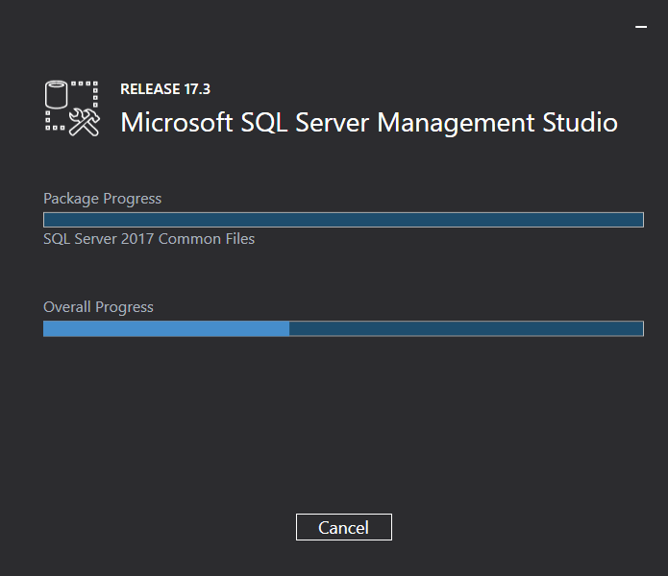

* Once setup is completed, click the **Close** button

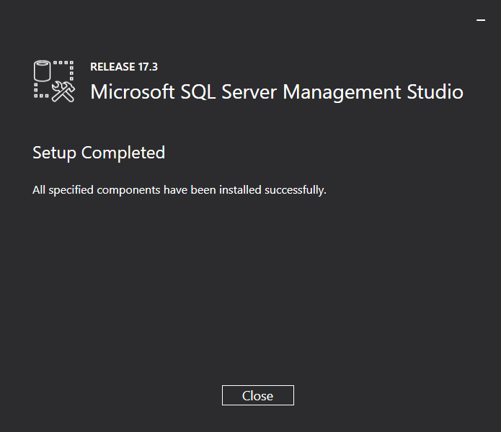

* Now, you should have a SQL Server 2017  and SQL Server Management Studio installed on your computer.

## **Connect to the SQL Server using SSMS**

* First, launch the Microsoft SQL Server Management Studio from the **Start** menu:

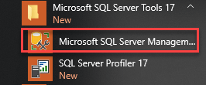

* Next, from the **Connect** menu under the **Object Explorer**, choose the **Database Engine**…

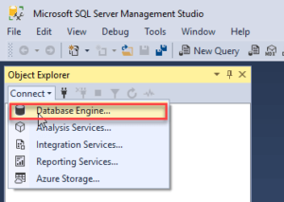

* Then, enter the information for the Server name (localhost), Authentication (SQL Server Authentication), and password for the  sa user and click the **Connect** button to connect to the SQL Server. Note that you should use the sa user and password that you entered during the [installation](https://www.sqlservertutorial.net/install-sql-server/).

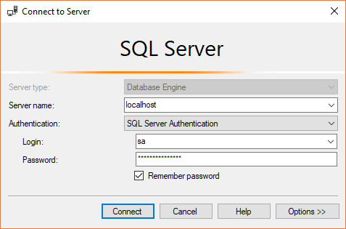

* If the connection is established successfully, then you will see the following **Object Explorer** panel:

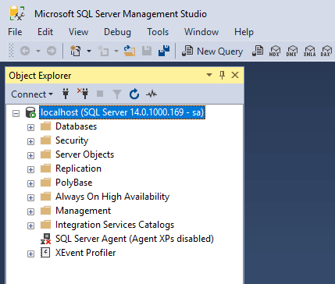

## **Execute a query**

* To execute a query you follow these steps:
* First, right-click on the **localhost (SQL Server …)** node and choose the **New Query** menu item:

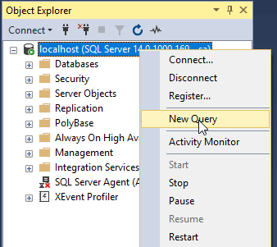

* Second, enter the following query in the Editor

|  |  |
| --- | --- |
| 1 | select @@version; |

* This query returns the version of the SQL Server.
* Third, click the **Execute** button.

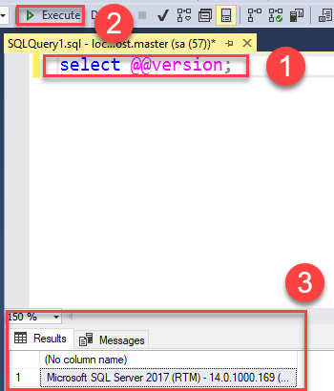

* The **Results** window shows the version of the SQL Server as shown in the above screenshot. A quick way to execute a query is to press the **F5** keyboard shortcut.
* Now, you should know how to connect to a SQL Server and execute a query from the SSMS.